James Zartman
METC-237
Lab 2 skill 6
Skill 6-1
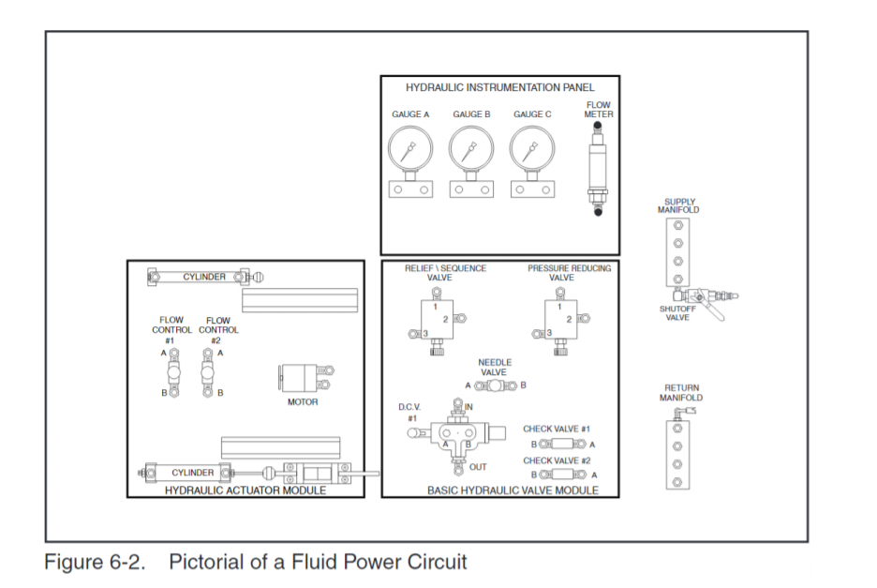

Skill 6-3
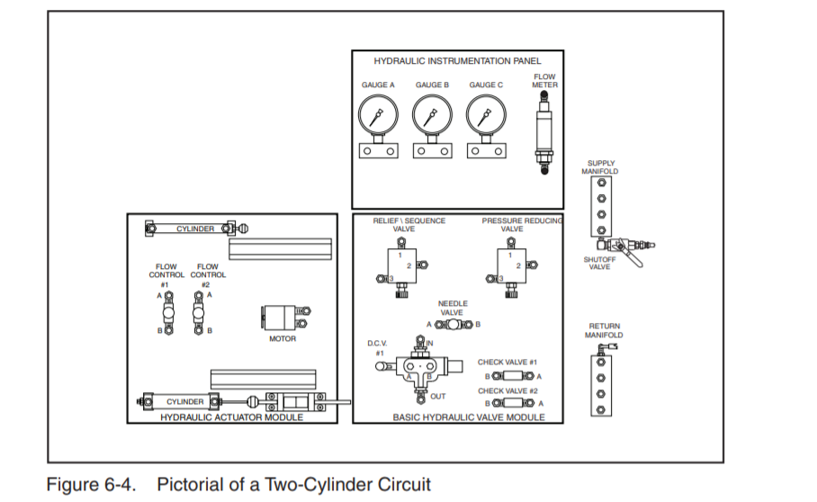

Skill 6-5
